]
Dear Editors,

I submit the manuscript "Topologically Protected Qubit Gate Configurations from Hyperbolic 3-Manifold Holonomy" for consideration as a Regular Article in the Journal of Mathematical Physics.
The paper proves two theorems about the structure of PSL(2,C) holonomy representations of compact hyperbolic 3-manifolds viewed as qubit gate configurations. The Covering Tower Invariance Theorem establishes that the optimal gate triple reproducing the PMNS lepton mixing matrix is a topological invariant of the Z/5-preserving covering tower of the manifold m003. The Homology Class No-Go Theorem establishes that gate triples with homology class collision have vanishing Jarlskog CP-violation invariant, providing a topological obstruction to CP-violating quantum operations.
The manuscript was previously submitted to Physical Review Research, which declined it as outside their scope. The mathematics is the primary contribution; the connection to Standard Model flavor physics is motivation and application. A preprint is available at SSRN (Abstract ID: 6687838).
All results are computed from SnapPy census data and are fully reproducible.

Yours sincerely,
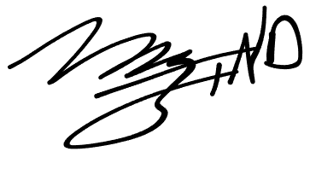

Marvin L. Gentry drmlgentry@protonmail.com ORCID: 0009-0006-4550-2663

